Bonjour and Welcome to le Cercle Français!

1. What is le Cercle Francais ?
2. Dues
   1. $5.00
   2. Check or $ to the main office, Mlle Hill doesn’t want your money! She’ll spend it on Big Macs.
   3. Due 10/17
3. Officer Nominations
   1. Should I be an officer if I’m unreliable and lazy?
      1. Le Président
      2. Le Vice Président
      3. La Secretaire/ Le Tresorier
      4. Club Promotors/Swag Handlers
4. Ideas for Future Projects
5. T Shirt Prelim Voting – $10 or less

Les Dates Importantes

* Officer Self Nominations by Friday 10/12
* Wednesday 10/17 at 3:20pm for T Shirt voting/Officer voting - if you can’t make it, see Mlle Hill for a ballot
* Wednesday 10/17 Club Dues are due to the Main Office

Like us on Facebook!

[www.facebook.com/ghsfc](http://www.facebook.com/ghsfc)

[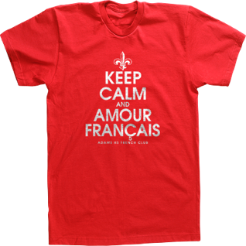](https://www.imagemarket.com/Projects/EditDesign?templateId=10284)



[](https://www.imagemarket.com/Projects/EditDesign?templateId=10459)



[](https://www.imagemarket.com/Projects/EditDesign?templateId=10460)

[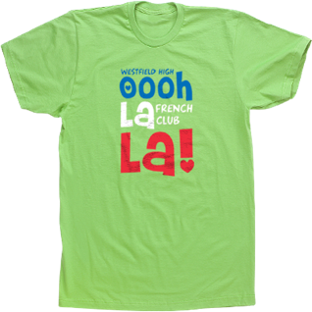](https://www.imagemarket.com/Projects/EditDesign?templateId=9823)



[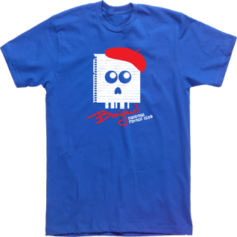](https://www.imagemarket.com/Projects/EditDesign?templateId=10442)



[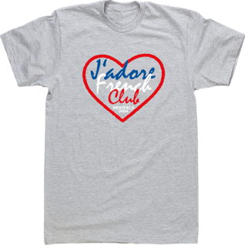](https://www.imagemarket.com/Projects/EditDesign?templateId=9831)



[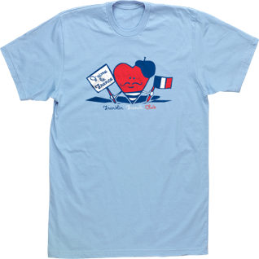](https://www.imagemarket.com/Projects/EditDesign?templateId=10071)



[](https://www.imagemarket.com/Projects/EditDesign?templateId=9558)



[](https://www.imagemarket.com/Projects/EditDesign?templateId=9471)



[](https://www.imagemarket.com/Projects/EditDesign?templateId=10608)



[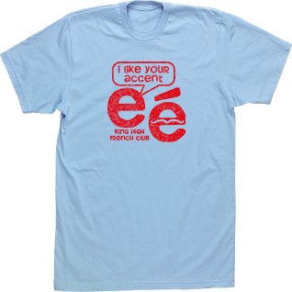](https://www.imagemarket.com/Projects/EditDesign?templateId=10606)



[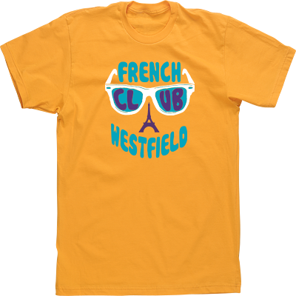](https://www.imagemarket.com/Projects/EditDesign?templateId=9844)



[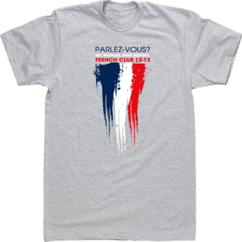](https://www.imagemarket.com/Projects/EditDesign?templateId=9209)

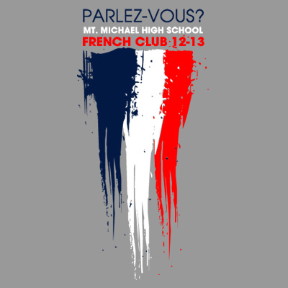

[](https://www.imagemarket.com/Projects/EditDesign?templateId=9502)

